Breakfast Wrap
Your choice of bacon, ham, chorizo or sausage, mixed with
Eggs, hash browns, and cheese, wrapped in a tortilla

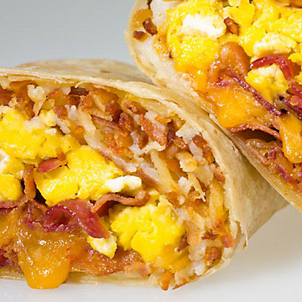

Large $4.39 Small $2.69

