GREEK CHICKEN
Grilled CHICKEN
FETA CHEESE, ONION AND TOMATO
GREEK DRESSING ON A PITA BREAD
$5.79
WITH FRIES AND SLAW-Add $2.25 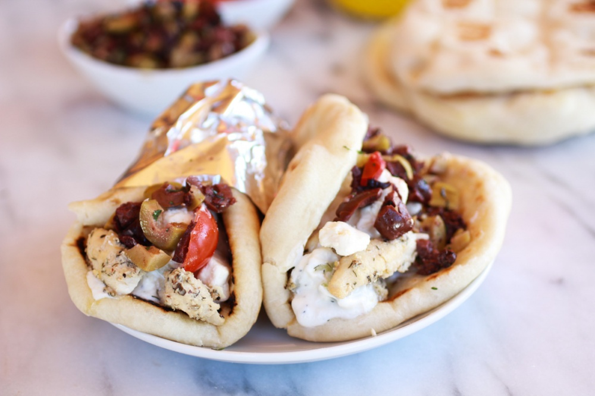
1 Sandwich

